**CSCE 4523 Database Management Systems**

**Project**

**By: Aayushi Saxena**

**Url(s): http://130.184.76.38:5000/**

**Peace Living***-Modern apartments for comfortable living*

**Objectives**

The objectives of this project are to:

* Build a web application that allows users to manage dorm room assignments.
* Implement and connect a MySQL database with multiple tables using foreign key relationships.
* Enable core functionality such as viewing assignments, available rooms, roommate matches, and building-wide reports.
* Practice SQL joins, conditional filtering, sorting, and aggregation.
* Create a professional web interface with clean styling and intuitive navigation.

**Approach**

* **Backend**: Python Flask
* **Database**: MySQL
* **Frontend**: HTML, CSS, Bootstrap-style responsive layout
* **Hosting**: Turing
* **Assets**: Custom background image dorm.jpg, images of building, dorm and dining hall in footer

**Web Page Design:**

* A responsive homepage with clear navigation buttons for each function
* Styled using a custom CSS file (style.css)
* Dorm room image as background for a warm, welcoming feel
* Bootstrap-style button layout using grid CSS

**Database Design**

**Tables:**

* Building(BuildingId, Name, Address, HasAC, HasDining)
* Room(BuildingId, RoomNumber, NumBedrooms, PrivateBathrooms, HasKitchen, HasAC, HasDining)
* Student(StudentId, Name, WantsAC, WantsDining, WantsKitchen, WantsPrivateBathroom)
* Assignment(StudentId, BuildingId, RoomNumber)

-Relational integrity is enforced using foreign keys.

**Function 1: Add Student**

* Allows adding a student with preference checkboxes
* Error if fields are left empty

**Function 2: Assign Student to Room**

* Assigns selected student to selected room
* Prevents duplicate assignment

**Function 3: View Assignments by Building**

* Shows students in rooms, sorted by name

**Function 4: View Rooms**

* Shows rooms sorted by BuildingId, with available beds

**Function 5: View Available Rooms for a Student**

* Uses student’s preferences to match rooms
* If no match, shows "No rooms found"

**Function 6: Roommate Matches**

* Finds students with exact matching preferences
* If no match, shows "No matches found"

**Function 7: Building Summary Report**

* Aggregated totals per building:
  + Total rooms
  + Total beds
  + Rooms with space left

**Function 8 : Complex Join**

* Query joins Assignment, Room, Student to report full housing layout
* Lists students who want AC, are placed in AC rooms, and live in buildings with dining

**Discussion**

**What Worked Well:**

* Flask routing and page templating
* SQL joins and conditionals for matching
* Template reuse and navigation layout
* Deployment via SSH and port forwarding to Turing

**What Didn’t:**

* Roommate match logic was initially strict; loosened filter helped

**Validation and Error Handling**

* Form inputs validated
* Checked room compatibility before assignment
* Error messages displayed using flash
* Defined fallback functions

**Screenshots**

1. **Homepage** – showing all function links

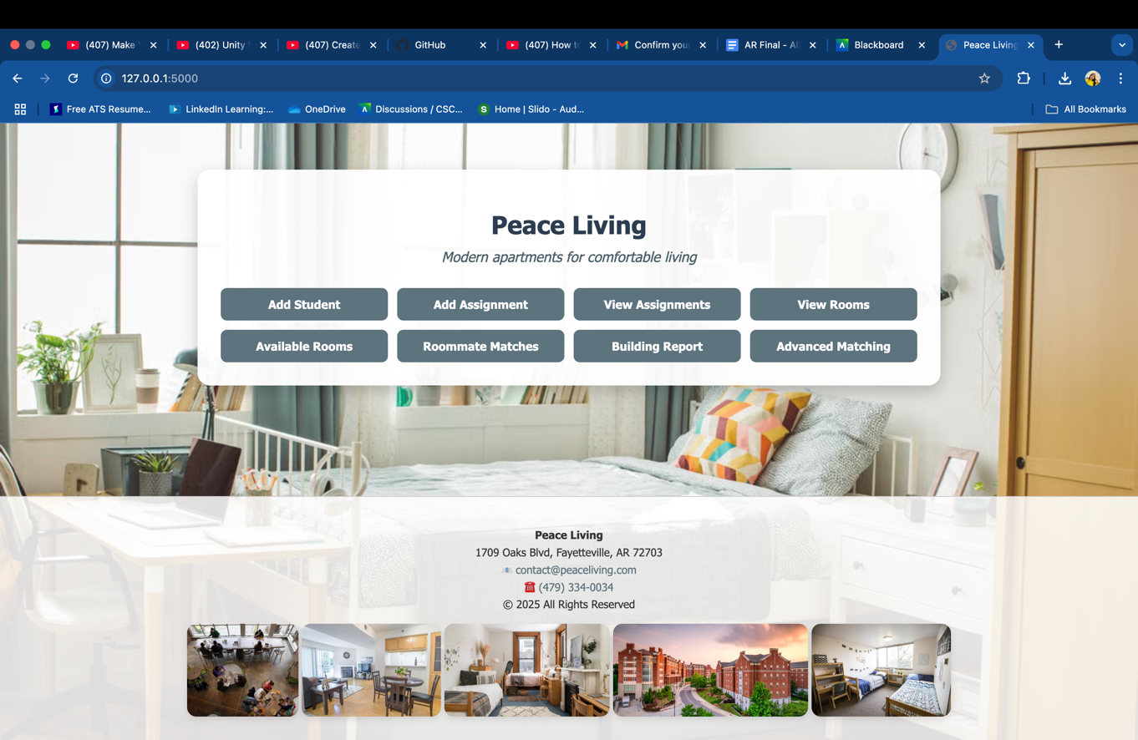

1. **Add Student Form** – filled in with sample data

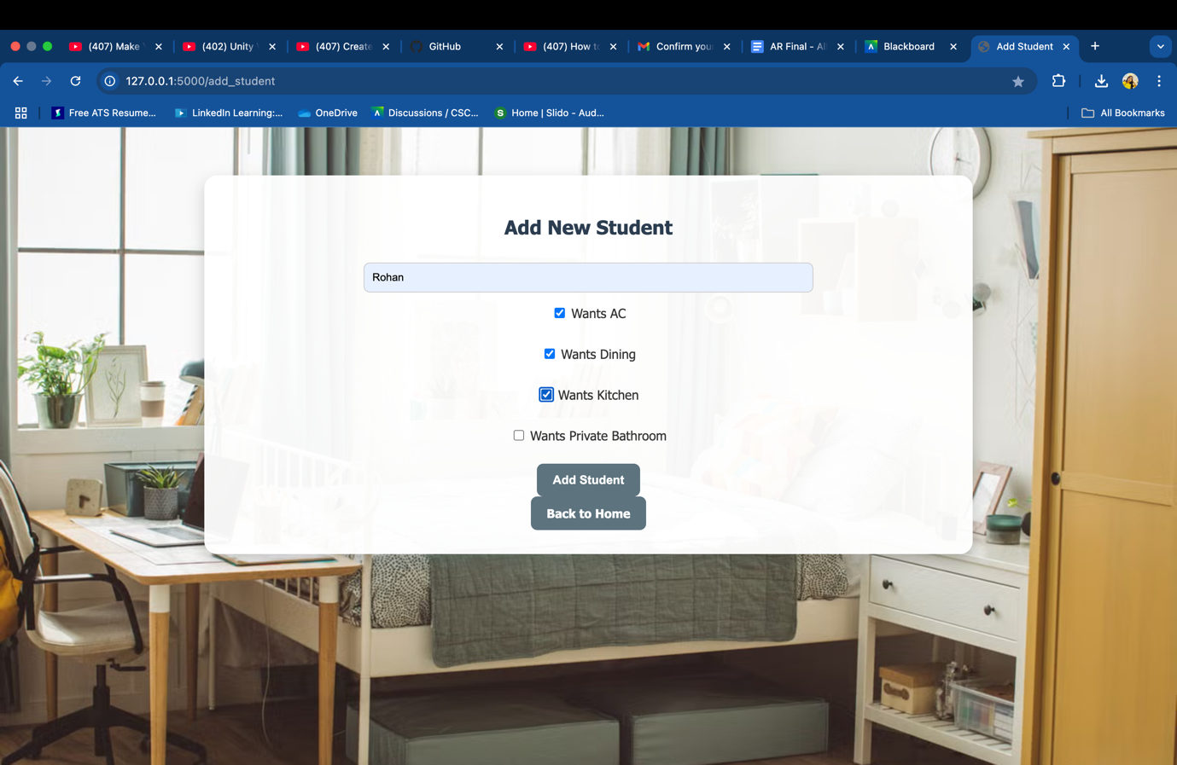

1. **Add Assignment Form** – dropdowns with students and rooms

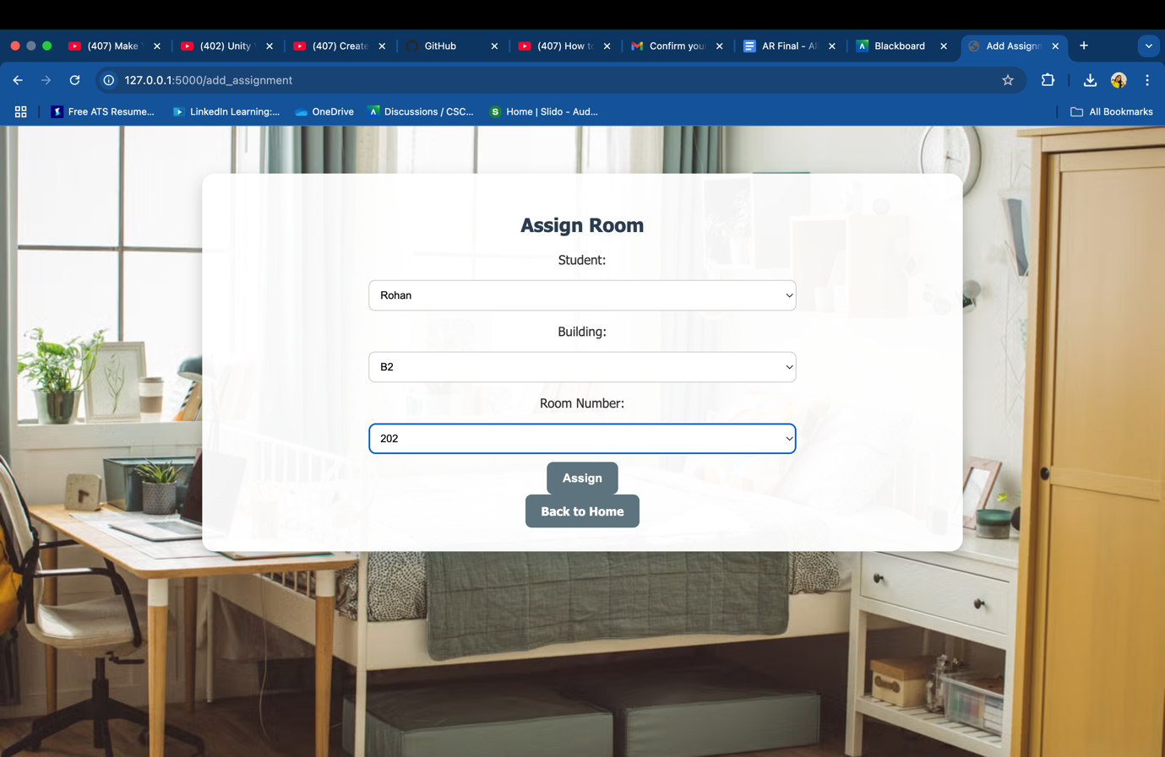

1. **View Assignments** – showing students with rooms

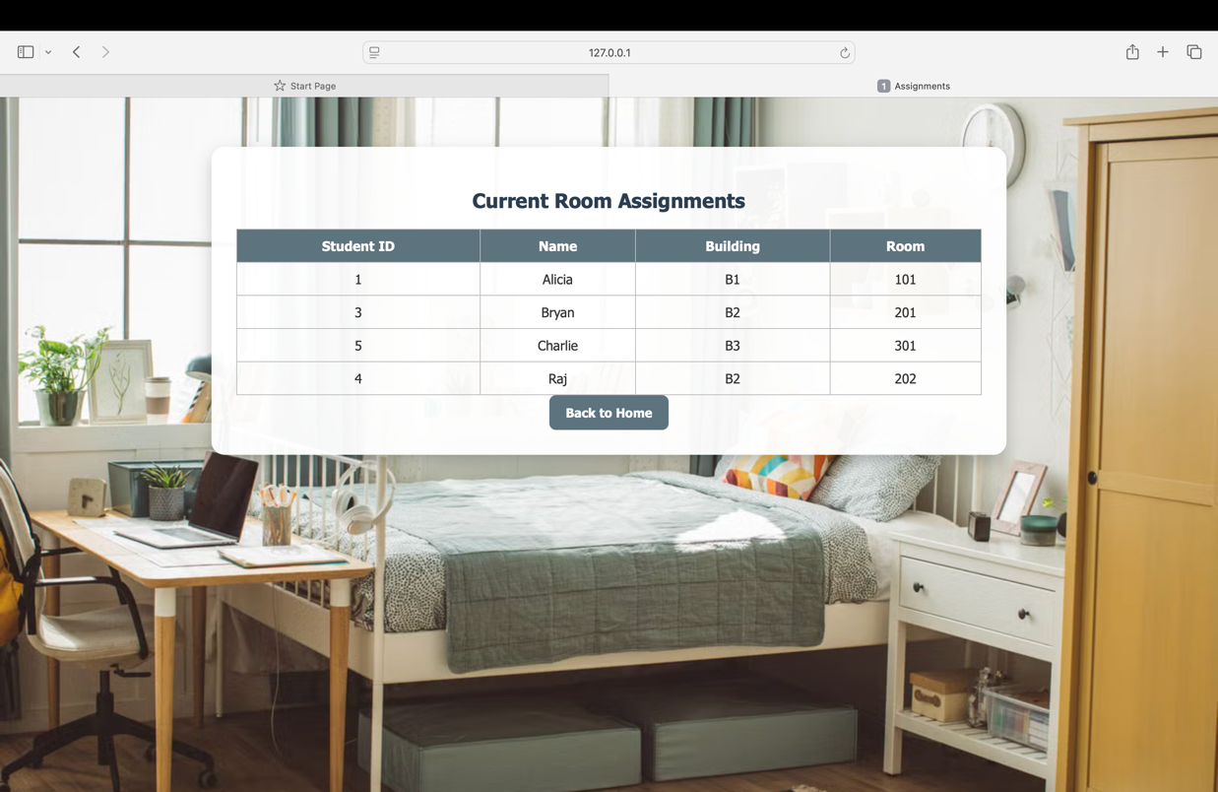

1. **View All Rooms** – building-wise room listing

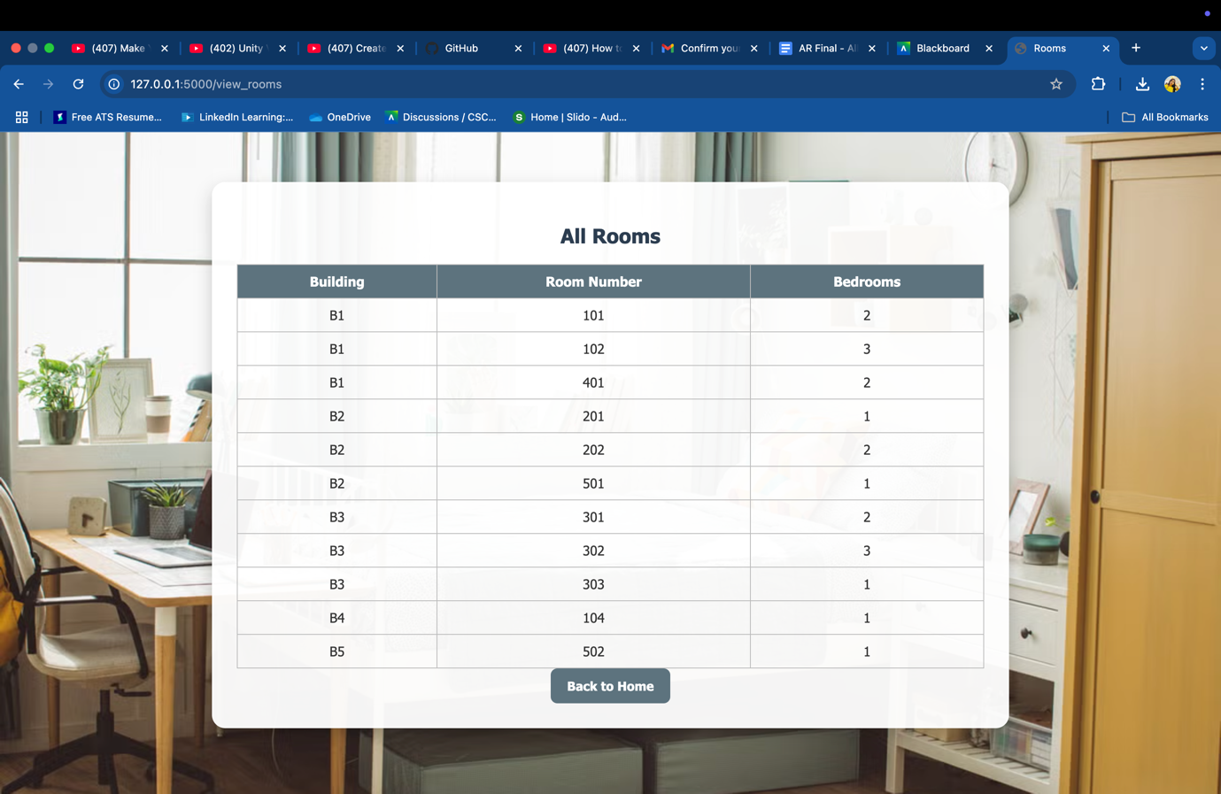

1. **Available Rooms for a Student** – matching filtered rooms

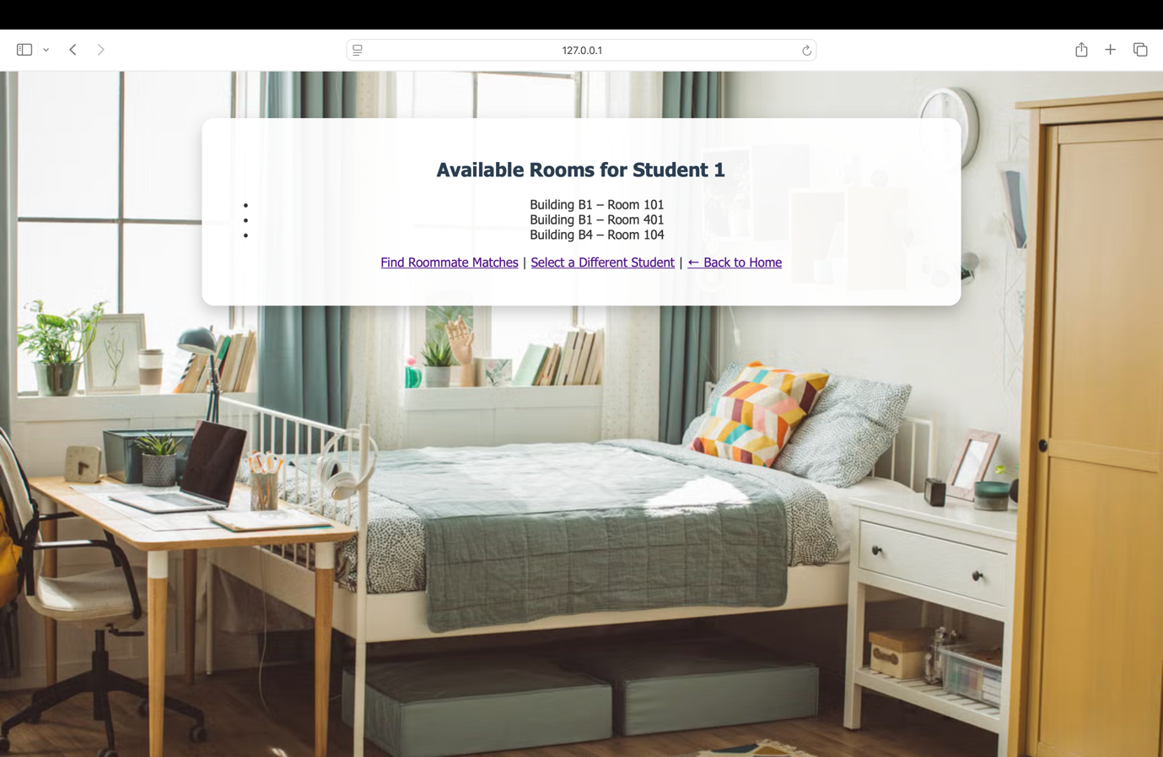

1. **Compatible Roommates** – matching students

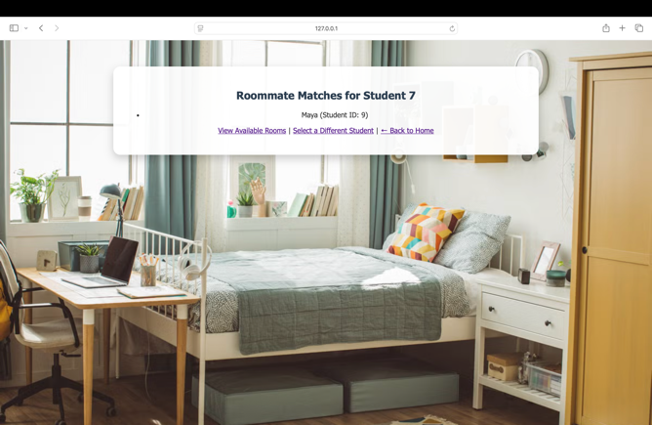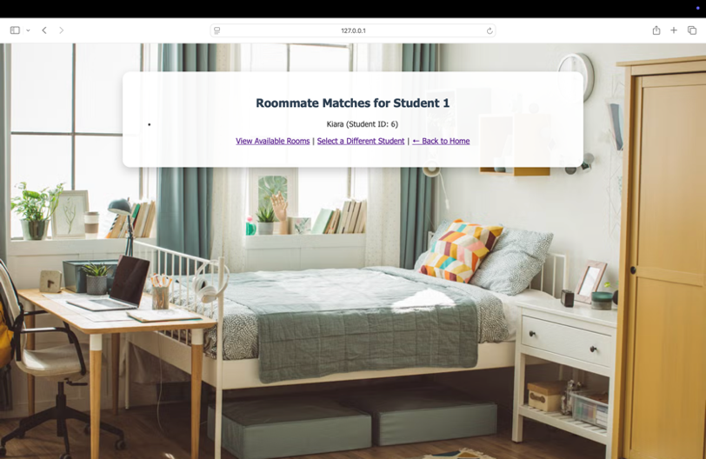

1. **Building Report** – with stats table

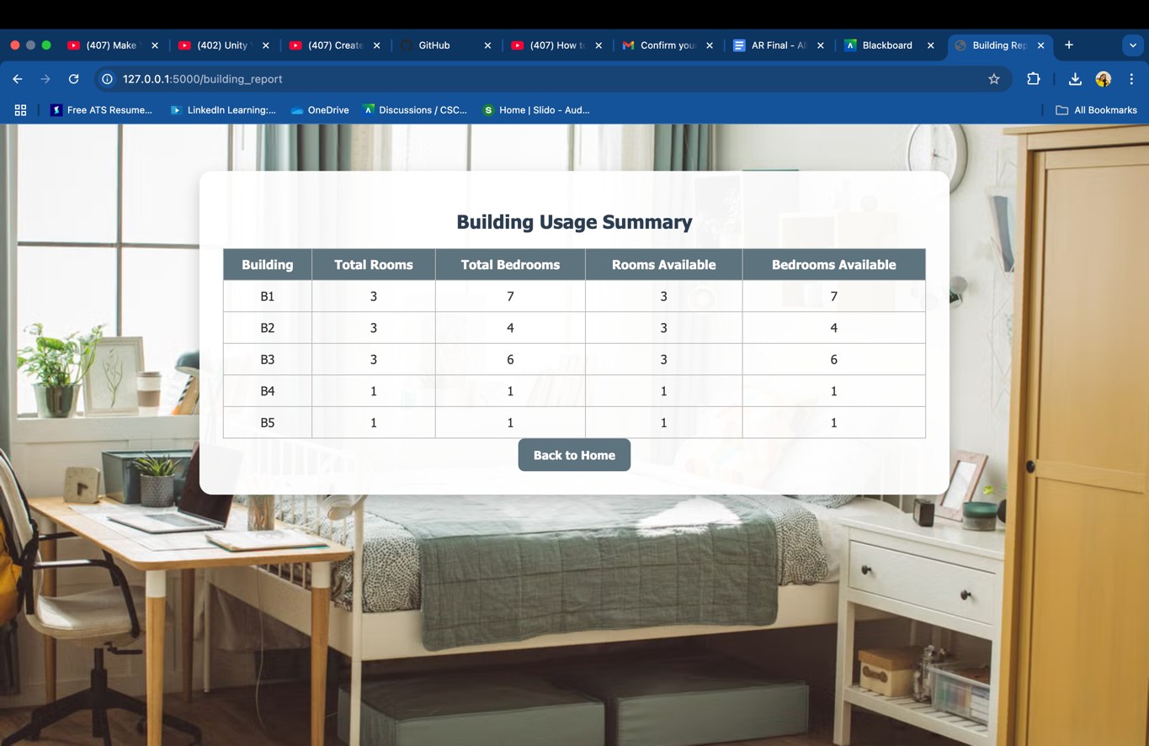

1. **Advanced Matching** – complex join output

